**COMPILED REPORT**

The project greatly determines and gives the visualization after each model application so it begins with importing all the libraries like pandas, matplotlib, NumPy and seaborn at the very start preceded by importing of the dataset as shown.

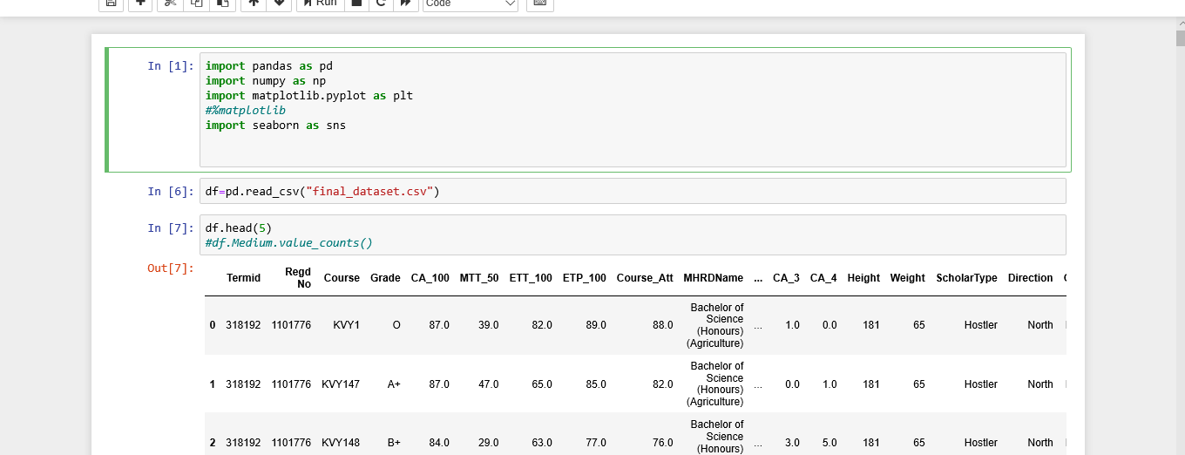

After importing the all the libraries we can simply select the data that is assigned.

As shown

import os

import pandas as pd

df = pd.read_csv('DATA-FINAL.csv')

if os.path.isfile('Mydata1.csv'):

print("not create again");

else:

lst = [['Termid','RegdNo','Course','Grade','CA_100','MTT_50','ETT_100','ETP_100','Course_Att','MHRDName','CA_1','CA_2','CA_3','CA_4','Height','Weight','ScholarType','Direction','Gender','Medium','CourseType','ProgramType']]

d= pd.DataFrame(lst)

for i in range(df.Termid.count()):

if i == 0:

d.to_csv('Mydata1.csv',mode='a',header=False)

if df.MHRDName[i] == "Bachelor of Science (Honours) (Agriculture )" :

df.iloc[i:i+1,:].to_csv('Mydata1.csv',mode='a',header=False)

else:

pass

it is the time of check for the types of all the columns and handing the missing values so to get a count of missing values one can type df.isnull().sum(axis=0)

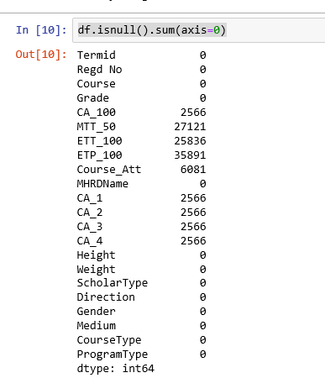

Handing the missing values:

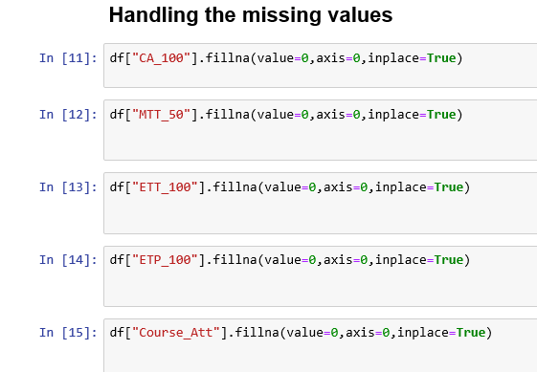

After plotting boxplot:

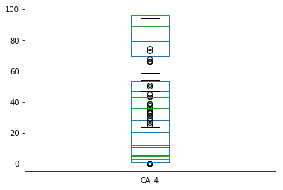

After plotting Histrogram:

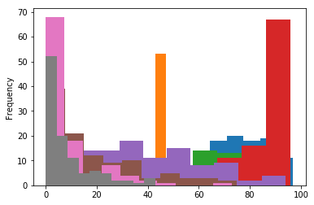

After finding correlation:

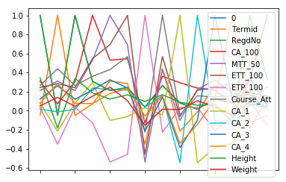

After handing the missing values we will apply different classification technique:

1. Support Vector Machines.
2. Linear Classifiers: Logistic Regressio
3. Support Vector Machines.
4. Decision Trees.
5. Random Forest.

The grade predicted by different classification algorithm are given below::::::::

The accuracy predicted by SVM Using rbf Kernel is 0.6666666666666666

The accuracy predicted using Random forest is 0.5151515151515151

The accuracy predicted using Logistic Regression 0.5454545454545454

The accuracy predicted using Decision Tree is 0.48148148148148145